Ultrasonic Ranging Module HC - SR04

# Product features:

Ultrasonic ranging module HC - SR04 provides 2cm - 400cm non-contact measurement function, the ranging accuracy can reach to 3mm. The modules includes ultrasonic transmitters, receiver and control circuit. The basic principle of work:

1. Using IO trigger for at least 10us high level signal,
2. The Module automatically sends eight 40 kHz and detect whether there is a pulse signal back.
3. IF the signal back, through high level , time of high output IO duration is the time from sending ultrasonic to returning.

Test distance = (high level time×velocity of sound (340M/S) / 2,

# Wire connecting direct as following:

* 5V Supply
* Trigger Pulse Input
* Echo Pulse Output
* 0V Ground

# Electric Parameter

|  |  |
| --- | --- |
| **Working Voltage** | **DC 5 V** |
| **Working Current** | **15mA** |
| **Working Frequency** | **40Hz** |
| **Max Range** | **4m** |
| **Min Range** | **2cm** |
| **MeasuringAngle** | **15 degree** |
| **Trigger Input Signal** | **10uS TTL pulse** |
| **Echo Output Signal** | **Input TTL lever signal and the range in**  **proportion** |
| **Dimension** | **45*20*15mm** |

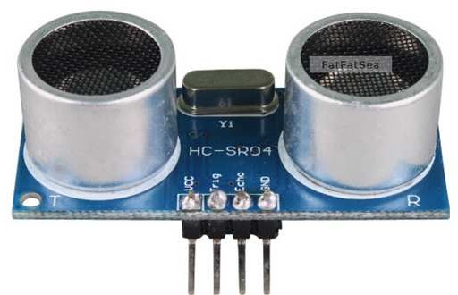

**Vcc Trig Echo GND**

# Timing diagram

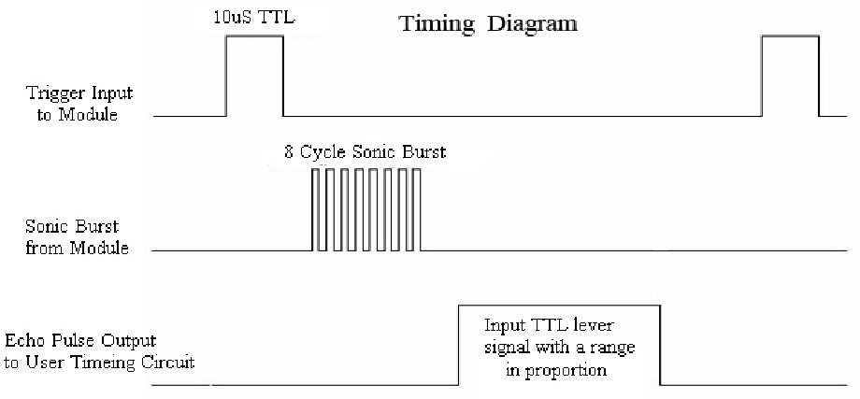The Timing diagram is shown below. You only need to supply a short 10uS pulse to the trigger input to start the ranging, and then the module will send out an 8 cycle burst of ultrasound at 40 kHz and raise its echo. The Echo is a distance object that is pulse width and the range in proportion .You can calculate the range through the time interval between sending trigger signal and receiving echo signal. Formula: uS / 58 = centimeters or uS / 148 =inch; or: the range = high level time * velocity (340M/S) / 2; we suggest to use over 60ms measurement cycle, in order to prevent trigger signal to the echo signal.

# Attention:

* The module is not suggested to connect directly to electric, if connected electric, the GND terminal should be connected the module first, otherwise,

it will affect the normal work of the module.

* When tested objects, the range of area is not less than 0.5 square meters and the plane requests as smooth as possible, otherwise ,it will affect the results of measuring.

Ultrasonic Sensor Working Principle

In industrial applications, an ultrasonic detection used to detect hidden tracks, discontinuities in metals, composites, plastics, ceramics, and for water level detection. For this purpose, the laws of physics which are indicating the propagation of sound waves through solid materials have been used since [**ultrasonic sensors**](https://robu.in/product-category/sensor/ultrasonic-sensor/) using sound instead of light for detection. In this blog, we are going to learn about the ultrasonic sensor working principle and its applications.

# Introduction to Ultrasonic Sensor

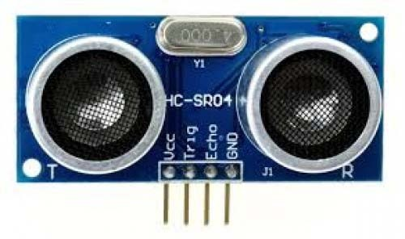Ultrasonic sensors work by emitting sound waves at a frequency which is too high for humans to hear.

An above image shows the [**HC-SR-04 ultrasonic sensor**](https://robu.in/product/hc-sr04-ultrasonic-range-finder/) which has transmitter, receiver. The pin configuration is,

* **VCC** – +5 V supply
* **TRIG** – Trigger input of sensor. Microcontroller applies 10 us trigger pulse to the HC-SR04 ultrasonic module.
* **ECHO**–Echo output of sensor. Microcontroller reads/monitors this pin to detect the obstacle or to find the distance.
* **GND** – Ground

Sound is a mechanical wave traveling through the mediums, which may be a solid, or liquid or gas. Sound waves can travel through the mediums with specific velocity depends on the medium of propagation. The sound waves which are having high frequency reflect from boundaries and produce distinctive echo patterns.

## Features of an Ultrasonic Sensor

1. Supply voltage: 5V (DC).
2. Supply current: 15mA.
3. Modulation frequency: 40Hz.
4. Output: 0 – 5V (Output high when obstacle detected in range).
5. Beam Angle: Max 15 degrees.
6. Distance: 2 cm – 400 cm.
7. Accuracy: 0.3cm.
8. Communication: Positive TTL pulse.

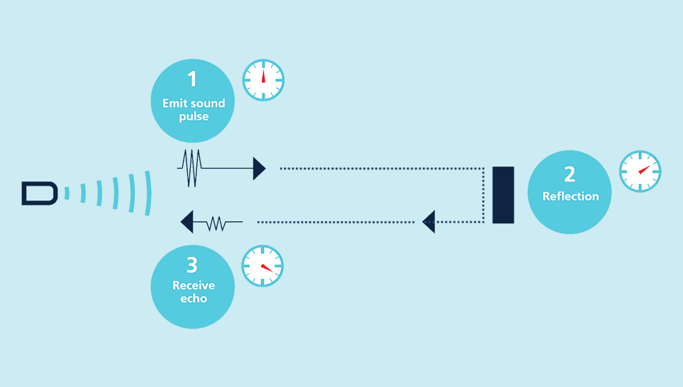

# Ultrasonic Sensor Working Principle

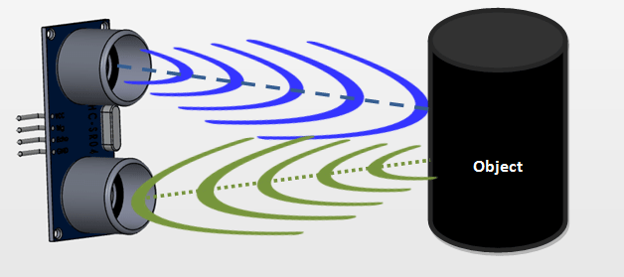Ultrasonic sensors emit short, high-frequency sound pulses at regular intervals. These propagate in the air at the velocity of sound. If they strike an object, then they reflected back as an echo signals to the sensor, which itself computes the distance to the target based on the time-span between emitting the signal and receiving the echo.

An [**ultrasonic sensors**](https://robu.in/product-category/sensor/ultrasonic-sensor/) are excellent at suppressing background interference. Virtually all materials which reflect sound can be detected, regardless of their colour. Even transparent materials or thin foils represent no problem for an ultrasonic sensor.

microsonic ultrasonic sensors are suitable for target distances from 20 mm to 10 m and as they measure the time of flight they can ascertain a measurement with pinpoint accuracy. Some of our

sensors can even resolve the signal to an accuracy of 0.025 mm. Ultrasonic sensors can see through dust-laden air and ink mists. Even thin deposits on the sensor membrane do not impair its function.

## Timing Diagram of Ultrasonic Sensor

1. First need to transmit trigger pulse of at least 10 us to the [**HC-SR04**](https://robu.in/product/hc-sr04-ultrasonic-range-finder-cartoon-ultrasonic-sensor-mounting-bracket/) Trig Pin.
2. Then the HC-SR04 automatically sends Eight 40 kHz sound wave and wait for rising edge output at Echo pin.
3. When the rising edge capture occurs at Echo pin, start the Timer and wait for falling edge on Echo pin.
4. As soon as the falling edge captures at the Echo pin, read the count of the Timer. This time count is the time required by the sensor to detect an object and return back from an object.

## How to calculate Distance?

If you need to measure the specific distance from your sensor, this can be calculated based on this formula:

We know that, **Distance= Speed* Time.** The speed of [sound waves](https://en.wikipedia.org/wiki/Sound) is 343 m/s. So,

### Total Distance= (343 * Time of hight(Echo) pulse)/2

Total distance is divided by 2 because signal travels from HC-SR04 to object and returns to the module HC-SR-04.

# Applications of an Ultrasonic Sensor

* It Uses to avoid and detect obstacles with robots like biped robot, obstacle avoider robot, [path](https://robu.in/non-looped-maze-solving-robot-with-mc40a/) [finding robot](https://robu.in/non-looped-maze-solving-robot-with-mc40a/) etc.
* It Used to measure the distance within a wide range of 2cm to 400cm.
* Used to map the objects surrounding the sensor by rotating it.
* Depth of certain places like wells, pits etc can be measured since the waves can penetrate through water.

Hope this article helps you to understand the applications and ultrasonic sensor working principle. To know more, refer the below blogs,